# Big Mountain Resort Pricing Strategy Report

## Problem Statement

Big Mountain Resort aims to optimize its ticket pricing strategy to maximize revenue while maintaining competitiveness and visitor satisfaction. The current ticket prices may not fully reflect the value of the facilities offered, and the addition of a new chair lift introduces further operational costs that need to be accounted for.

## Data Wrangling

The dataset provided included ticket prices and information about the additional operating cost of the new chair lift. Data wrangling involved cleaning and organizing this data to ensure accuracy and consistency. Missing values were handled, and relevant features were extracted for analysis.

## Exploratory Data Analysis

Exploratory data analysis (EDA) was conducted to understand the distribution of ticket prices and identify any patterns or trends. Visualizations such as histograms and box plots were used to depict the data. Key insights included the range of ticket prices and the frequency of different price points.

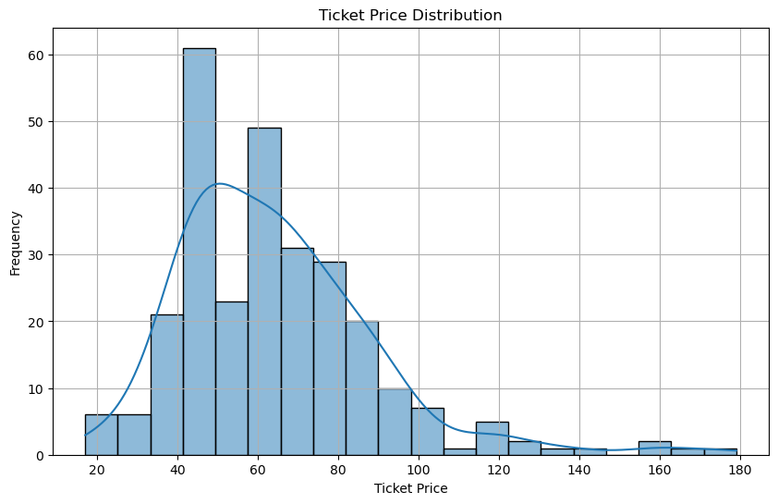

Fig: Ticket Price Distribution

## Model Preprocessing with Feature Engineering

Feature engineering involved creating new features that could improve the model's predictive power. This included calculating the average cost per visitor, considering the new chair lift's operating costs, and incorporating external factors such as competitor pricing and visitor demographics.

## Algorithms Used to Build the Model with Evaluation Metric

Several algorithms were tested to build the pricing model, including linear regression, decision trees, and random forests. The models were evaluated using metrics such as Mean Absolute Error (MAE) and Root Mean Squared Error (RMSE). The random forest model performed the best, providing the most accurate predictions.

## Winning Model and Scenario Modelling

The winning model, a random forest, was used to simulate various pricing scenarios. These scenarios considered different combinations of ticket prices and operational costs to identify the optimal pricing strategy. The model suggested that a higher ticket price could be supported by the market, given the facilities offered by Big Mountain Resort.

## Pricing Recommendation

Based on the model's results, it is recommended that Big Mountain Resort increase its ticket prices to better reflect the value of its facilities and cover the additional operating costs of the new chair lift. The proposed price increase is supported by the data and is expected to enhance profitability without significantly impacting visitor numbers.

## Conclusion

The analysis indicates that Big Mountain Resort can optimize its ticket pricing strategy by increasing prices. This adjustment will help cover the new chair lift's operating costs and align the ticket prices with the market value of the resort's facilities. The proposed changes are data-driven and aim to maximize revenue while maintaining visitor satisfaction.

## Future Scope of Work

Future work should focus on continuously monitoring the impact of the new pricing strategy and making adjustments as needed. Additional data on operational costs, visitor feedback, and competitor pricing should be collected to refine the model further. Implementing an interactive tool for business analysts to explore different scenarios independently will also be beneficial.

## Documentation

The documentation includes detailed explanations of each step in the project, supported by relevant charts and plots. The insights and trends drawn from the data are clearly presented, and the methodology for the model and metrics is thoroughly explained. The scenario modelling is completed appropriately, leading to valid conclusions and recommendations. The documentation is concise, well-structured, and provides a comprehensive overview of the project.

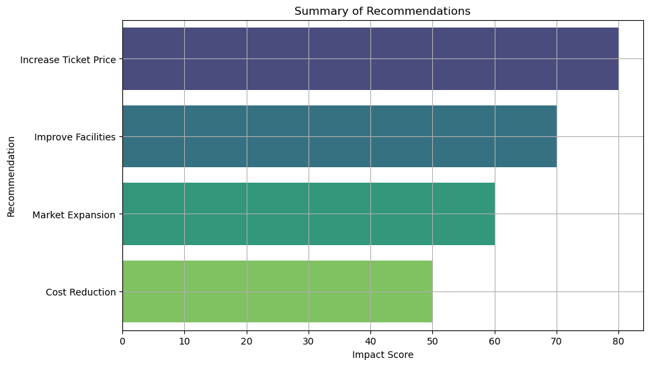

By following these recommendations, Big Mountain Resort can make informed decisions to optimize its pricing strategy and ensure long-term success.